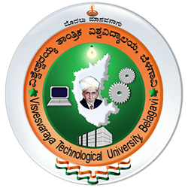
Visvesvaraya Technological University
(State University of Government of Karnataka Established as per the VTU Act, 1994)
“Jnana Sangama”, Belagavi-590018, Karnataka

NOTES ON
Corporate Strategy

MODULE#1

By:
Dr.Umesh Bhushi
Professor Emeritus
Department of Management Studies
Visvesvaraya Technological University Belagavi-590018
Email: umesh.bhushi@vtu.ac.in

Department of Management Studies
Master of Business Administration
Visvesvaraya Technological University Belagavi-590018

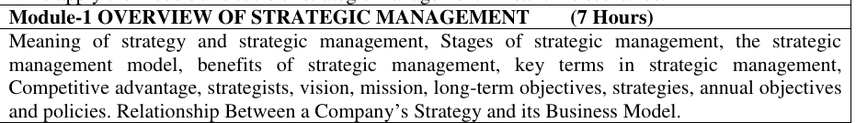
Note theses notes are just a precursor insights for basic understanding but you must refer text books prescribed for detailed information

1. Meaning of Strategy and Strategic Management
- Strategy: It is a long-term plan to achieve specific goals and outperform competitors and gain a competitive advantage. It provides direction and scope for the organization.
- Strategic Management: The process of planning, implementing, and evaluating strategies to meet organizational objectives.
  - It aligns company resources with its environment and goals.
  - It helps firms adapt to changes and stay competitive.
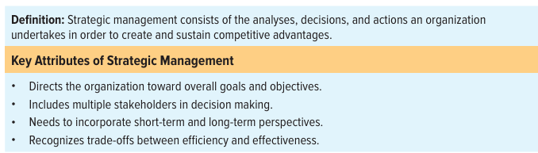

Strategic Planning is concerned with:
- Future [Long term effects].
- Environment [The adaptability of business to the Changing environment]
- Growth [Pace, expansion, Direction and time]
- Portfolio of business [Product – Market Scope, and Position like
- First mover advantage Core Competencies [Increasing organizational capability]

2. Stages of Strategic Management
- Strategy Formulation: Defining vision, mission, external(PESTEL)/internal analysis(SWOT), setting objectives, and choosing strategies.
- Strategy Implementation: Putting strategies into action through resources, structure, and policies, hence allocating resources, assigning tasks, and executing the plan
- Strategy Evaluation: measuring results, monitoring progress, and making necessary changes, reviewing strategies, and making adjustments. Feedback is collected continuously at each stage. The stages are dynamic and often overlap.

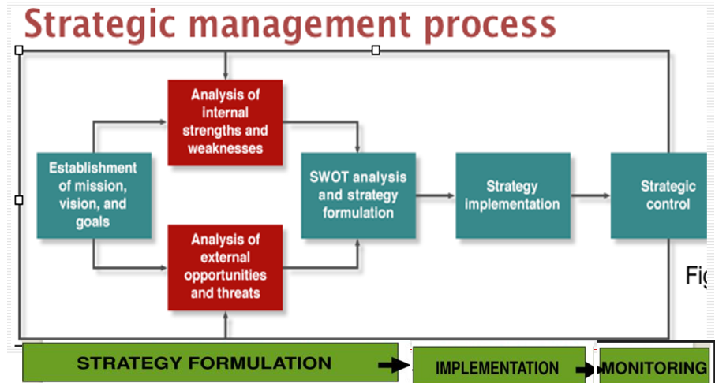
(Note in the above diagram there has to be a iteration process to accommodate the dynamic changes back and forth arrows in opposite directions)

3. Strategic Management Model
A step-by-step framework:
- Define vision and mission
- Conduct external (PESTLE, industry) and internal (SWOT, value chain) analysis.
- Set objectives (long-term and annual).
- Formulate strategies at various levels (corporate, business, functional) and Choose strategies
- Implement strategies
- Monitor performance, Evaluate and control

4. Benefits of Strategic Management
- It provides clear direction, purpose.and priorities
- Facilitate better resource allocation and Improves decision-making and coordination
- Enhances organizational performance by Improved performance and competitiveness
- Enhanced decision-making and helps manage change and uncertainty.
- Proactive rather than reactive behavior.
- Builds sustainable competitive advantage.

5. Key Terms in Strategic Management
- Strategy: Long-term action plan to achieve competitive advantage.
- Strategists: individuals responsible for strategy formulation and execution. To implement strategies
- Vision: A future-oriented statement of what the organization wants to become and is an inspirational statement
- Mission: Organization’s current purpose and scope of the business the and scope.
- Objectives: Specific outcomes to achieve goals
- Policies: Guidelines to support strategy implementation
6. Competitive Advantage
- The edge a company has over rivals by offering greater value (e.g., lower cost, unique product).
- Types: Cost leadership, differentiation, focus strategy, service, first mover advantage, (Innovative product), Lower gestation period (Less time to bring product to market)
- Leads to greater market share and profitability.
- Must be sustainable and not easily imitated.
- Built through innovation, quality, branding, or customer service.

7. Strategists
- Individuals responsible for strategic decisions (e.g., CEO, top managers, planners).
- They guide, influence, and implement strategic plans.
- Analyze internal and external environments.
- Make key decisions on resources and direction.
- Oversee strategy execution and adjustments.
- Influence organizational culture and leadership.

8. Vision
- Describes what the organization wants to become in the future.
- Provides inspiration and long-term focus.
- Helps align stakeholders toward common goals.
- Should be clear, challenging, and future-oriented.
Vision Statement of TATA Steel:
"To be the most respected and valuable steel company in the world."
Explanation:
- "Most Respected" – Tata Steel aims to earn trust and admiration through ethical practices, sustainability, and social responsibility.
- "Most Valuable" – The company strives to deliver consistent value to stakeholders – customers, employees, shareholders, and society.
- Global Aspiration – The phrase "in the world" reflects Tata Steel’s ambition to be a global leader, not just a top player in India.
Thus (Vision is about global leadership and respect in the steel industry)

9. Mission
- Defines the organization’s purpose, values, and primary goals.
- Explains what the company does and for whom and how
- Guides decision-making and strategic planning.
- Should reflect the organization’s values and identity.

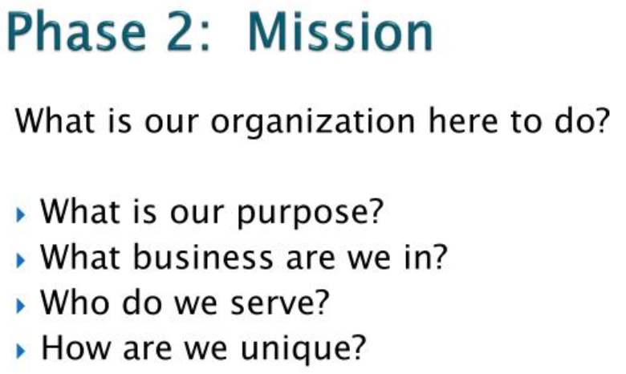

Mission Statement TATA Steel:
"We make the difference through our people, by creating value for all our stakeholders."
Explanation:
- Focus on People – The company emphasizes its employees as a core strength.
- Value Creation – Tata Steel aims to generate value not just for profits, but for all stakeholders including customers, investors, suppliers, and the community.
- Ethical and Sustainable Growth – Its actions are guided by the Tata Group’s core values: integrity, excellence, responsibility, unity, and pioneering.
Thus Mission is about value creation, people-centric growth, and responsible business practices
10. Long-Term Objectives
- Goals set to be achieved over 3–5 years or more.
- Help translate vision and mission into action
- Help guide the strategic direction by focusing on growth, profitability, market share expansion, etc.
- Provide direction for departments and teams.
- Objectives specific, measurable, achievable, relevant, and time-bound (SMART).

11. Strategies
- Action plans to achieve long-term objectives.
- Can be at different levels: corporate, business, functional.
- Help firms adapt to changing environments.
- Include growth, diversification, cost leadership, etc.
- Require resources, planning, and commitment.

12. Annual Objectives
- Short-term targets (usually 1 year) aligned with long-term goals/objectives.
- Usually set for one year.
- Help in tracking progress and measuring performance.
- Assigned to departments or teams.
- Support strategy implementation.

13. Policies
- Rules or guidelines that support strategy implementation.
- Guidelines or rules to ensure consistent decision-making.
- Help in implementing strategies effectively.
- Can be formal or informal.
- Cover areas like HR, finance, operations, etc.
- Ensure alignment with organizational goals.
- Help standardize decision-making and behavior.

14. Relationship Between a Company’s Strategy and its Business Model
- Business model describes how a company creates and delivers value.
- Strategy: How the company competes and achieves its goals within its business model.
- Relationship: Strategy supports the business model by defining how it will compete and sustain profitability. A strong strategy aligns with and strengthens the business model.

Both (Strategy and Business model) must be flexible to adapt to market changes.

Review the following videos to get complete glimpse of Strategic Management
https://www.youtube.com/watch?v=CMMUwNeBxyA
https://www.youtube.com/watch?v=5xD2JLleGqk&t=64s (Education leaves fundamental SP)
https://youtu.be/HQ6348u6o08 (15 min complete process)
Suggested Learning Resources:
Books 1. Strategic Management, Fred R. David, Prentice Hall India Publication.
2. Crafting and Executing Strategy: The Quest for Competitive Advantage – Concepts and CasesArthur A. Thompson Jr. Margaret A. Petera f John E. Gamble, A. J. Strickland III, Arun K. Jain, McGraw Hill Education, 16/e 2016
3. Contemporary Strategy Analysis, Robert M. Grant, Wiley India, 10e 4. . Strategic Management-Concepts and Cases, Upendra Kachru, Excel Books, New Delhi, 2005.

